2. Data and Methodology

2.1 Observations and Flow Regime Classification
Observational data was collected from a 201-MW wind farm located on a flat terrain in a desert Gobi in Hexi Corridor, Gansu, China. The farm is equipped with 134 wind turbines, each with a rated power of 1.5 MW, and a hub height of 61.5 m, and a rotor diameter of 82 m. A 70-m-height met mast was situated at the center of the western farm boundary (see map in Figure X). Vertical wind profiles were characterized by wind speeds at four heights (10, 30, 50, and 70 m) measured by the mast from May 2021 to October 2022. The sampling interval of the measurement is 15 min. Rigorous quality control, including missing value removal, anomaly detection, and gap filling (see Text S1 for details), was applied to the measured data. Given the location of the met mast relative to the turbine array, the mast could capture distinct flow regimes depending on wind direction. Winds in the sector of 225°-315° (west) could be classified as free-stream, while those in the 45°-135° (east) sector are classified as wake-influenced flow (Figure X). To ensure the reliability of the classification, flow regime was determined only when the wind directions at the four heights are consistent.

2.2 Analytical Framework
A multi-dimensional analysis framework was employed to reveal the physical mechanisms governing power production in the wind farm. First, we applied Complete Ensemble Empirical Mode Decomposition with Adaptive Noise (CEEMDAN, Torres et al., 2011) to decompose the time series of wind speed and farm-scale power generation into intrinsic mode functions, identifying the dominant timescales of variability across vertical layers. Second, Empirical Orthogonal Function (EOF) analysis (Wilks, 2011) was performed on the four-level wind profiles to extract the dominant vertical variation modes of wind speed, compensating for the lack of direct stability measurements (Text S3.2). Finally, we utilized a machine learning model (LightGBM, Ke et al., 2017) combined with SHAP (SHapley Additive exPlanations, Lundberg & Lee, 2017) values to quantify the importance of wind speeds at different heights and directions for power prediction. This approach allows us to mechanistically rank the contribution of multi-height winds and temperatures influenced by different flow regimes (free stream vs. wake-influenced flow) to the power generation of the wind farm (Liao et al., 2024).

2.3 Day-Ahead Forecasting Experimental Design
The forecasting target is day-ahead wind farm power output using Numerical Weather Prediction (NWP) inputs generated by the Weather Research and Forecasting (WRF) model. To account for NWP uncertainty, we utilized retrospective forecasts from two distinct dynamical downscaling configurations driven by the ECMWF-IFS (hereafter EC-WRF) and NCEP-GFS (hereafter GFS-WRF) archives, respectively (physics schemes in Table S2). The NWP fields were spatially and vertically interpolated to the farm location and mast heights (preprocessing in Text S2). To demonstrate the value of regime-dependent inputs, we designed 15 comparative experiments ranging from a single hub-height baseline to our proposed Physics-Informed Fusion Strategy (listed in Table S1). In this proposed strategy, input features are dynamically selected based on the predicted flow regime. Specifically, free-stream conditions utilize 10-m and 70-m wind speeds, whereas wake-affected conditions switch to 10-m and 30-m speeds based on SHAP-identified importance. Predictions from both NWP streams are then integrated via a correction-prediction two-step process. To prevent temporal data leakage, the dataset was split chronologically, with the first 80% used for training and the subsequent 20% reserved strictly for independent testing (see Text S3.5 for details). Model performance was evaluated using Root Mean Square Error (RMSE) and Spearman correlation coefficient, and the statistical significance was verified by the Diebold-Mariano (DM) test (formulas in Text S4).

SI outline
- Text S1. Data Quality Control and Preprocessing
- Text S2. Operational NWP Configuration and Temporal Scheduling
- Text S3. Methodological Principles
- Text S4. Evaluation Metrics and Statistical Significance
- Table S1. Summary of Experimental Strategies
- Table S2. Detailed configuration of the WRF model domains and physics parameterization schemes
- Table S3. Hyperparameter Configuration for LightGBM Models
- Figure S1. Observational setup and wind farm layout
- References

Text S1. Data Quality Control and Preprocessing
To ensure data integrity, rigorous quality control (QC) procedures were applied to the raw 15-minute observational datasets. The QC process involved three sequential steps: (1) Missing Value Removal: Any temporal record containing missing values (NaN) in either the meteorological mast data or the wind farm power logs was entirely discarded. (2) Anomaly Detection: We identified and removed "frozen" sensor data, defined as records where wind speed or power readings remained identical for three or more consecutive timestamps. (3) Gap Filling: Isolated missing values (single timestamps) were filled using linear interpolation from the immediately preceding and succeeding valid records. However, continuous gaps exceeding 30 minutes were left as missing to avoid introducing artificial trends.

Text S2. Operational NWP Configuration and Temporal Scheduling
To ensure the practical applicability of the forecasting strategies, the NWP data generation strictly adhered to the operational standards of the local grid dispatching center in Gansu. The day-ahead forecasting window targets the 24-hour period of the following day (Day+1, 00:00–23:45 BJT). The WRF model is initialized daily at 20:00 BJT (Beijing Time), utilizing the latest available global forcing data. A critical 28-hour operational latency exists between the model initialization and the start of the target forecast window, accounting for data transmission, computation, and the strict grid reporting deadline. Consequently, for each daily cycle, the first 28 hours are treated as a spin-up period and discarded. The subsequent 0–24 hour segment is extracted to evaluate day-ahead performance.
Regarding the model architecture, the WRF model (Version 4.2) was configured with nested domains to dynamically downscale the global forcing data. The GFS-driven configuration employed a three-domain nesting strategy with horizontal resolutions of 27, 9, and 3 km, whereas the EC-driven configuration adopted a two-domain strategy (9 and 3 km). Both configurations utilized 51 terrain-following vertical levels. Physics parameterizations included the Morrison 2-moment microphysics, RRTMG radiation, Noah Land Surface Model, and the Yonsei University (YSU) planetary boundary layer scheme (details in Table S2). This configuration follows the operational system systematically evaluated in Xia et al. (2026), ensuring computational stability and consistency across the 3-year hindcast period.

Text S3. Methodological Principles

Text S3.5 Model Implementation and Hyperparameter Settings
Input Feature Configuration: The input feature vector () was dynamically tailored to the specific experimental phase.
Diagnostic Phase (Observation-based): To maximize explanatory power for SHAP analysis, the input vector included raw observational variables alongside physics-informed engineering features—specifically wind speed cubics () to mimic the power curve, and temporal lags (1 h, 24 h) to capture system inertia.
Forecasting Phase (NWP-based): To ensure operational robustness and strictly prevent look-ahead bias in day-ahead scenarios, the input vector was restricted to raw meteorological variables (interpolated NWP wind speeds, direction, and temperature) without autoregressive lag terms. The model relied on its inherent non-linear mapping capability to capture power curve relationships directly from these inputs.
Data Splitting Strategy: To prevent temporal data leakage, the dataset was split chronologically, with the first 80% used for model training and validation, and the subsequent 20% reserved strictly for independent testing.
Hyperparameter Optimization: To ensure robust generalization and prevent overfitting, the LightGBM models (both for wind correction and power prediction) were trained using a Gradient Boosting Decision Tree (GBDT) backbone with an Early Stopping strategy. Instead of performing an exhaustive grid search for every fold, we employed a standardized set of hyperparameters that balance model complexity and training efficiency. Crucially, the number of boosting iterations (trees) was dynamically determined by monitoring the RMSE on the validation set. The training process automatically stopped if the validation error did not decrease for 10 consecutive rounds (stopping_rounds=10). This regularization technique ensures that the model captures the underlying physical patterns without memorizing noise. The specific hyperparameter configuration used in this study is detailed in Table S3.

Text S4. Evaluation Metrics and Statistical Significance

Text S4.1 Performance Metrics
To quantitatively evaluate the forecasting accuracy, we employed two standard metrics: Root Mean Square Error (RMSE) and the Spearman Rank Correlation Coefficient ().
The RMSE measures the average magnitude of the forecast errors:
Equation (X)
Given the inherent non-linear nature of wind power generation characteristics, we selected the Spearman Rank Correlation Coefficient () rather than the standard Pearson correlation. Spearman correlation assesses the monotonic relationship between predicted and observed sequences based on their ranks, offering greater robustness against outliers and non-linear dependencies:
Equation (X)
Where is the number of test samples, and is the difference between the ranks of the observed and predicted power values at time .

Text S4.2 Diebold-Mariano (DM) Test
To verify whether the improvement of the proposed strategy over the baseline is statistically significant, we applied the Diebold-Mariano (DM) test [Ref: Diebold & Mariano, 1995]. The test compares the forecast accuracy of two models based on their loss differentials.
Let and be the forecast errors of the baseline model and the proposed model, respectively. The loss differential sequence is defined using the squared error loss function:
Equation (X)
The DM test statistic is calculated as:
Equation (X)

Where is the sample mean of the loss differential, and is the asymptotic variance of . Under the null hypothesis (i.e., both models have equal predictive accuracy), the DM statistic follows a standard normal distribution . A positive DM value indicates that the proposed model has a smaller error than the baseline. In this study, we consider the improvement significant if the -value is less than 0.05 (confidence level of 95%).

Table S1. Summary of Experimental Strategies
Table S1. Detailed configuration of the 18 forecasting experimental strategies.
 | Strategy Name | NWP Source | Input Features (Heights) | Processing Flow
Baseline | G-70-P | GFS-WRF | 70 m (Hub-height) | End-to-End Power Prediction
Single-Level | G-10-P | GFS-WRF | 10 m | End-to-End Power Prediction
 | G-70-WP | GFS-WRF | 70 m | Wind Correction to Power
 | G-10-WP | GFS-WRF | 10 m | Wind Correction to Power
 | E-70-P | EC-WRF | 70 m | End-to-End Power Prediction
 | E-10-P | EC-WRF | 10 m | End-to-End Power Prediction
 | E-70-WP | EC-WRF | 70 m | Wind Correction to Power
 | E-10-WP | EC-WRF | 10 m | Wind Correction to Power
 | EG-70-WP | Both | 70 m (Dual-source) | Wind Correction to Power
 | EG-10-WP | Both | 10 m (Dual-source) | Wind Correction to Power
Multi-Level | G-B-WP | GFS-WRF | 10 m, 70 m | Profile Correction to Power
 | E-B-WP | EC-WRF | 10 m, 70 m | Profile Correction to Power
 | EG-B-WP | Both | 10 m, 70 m (All sources) | Profile Correction to Power
 | Fusion-B-WP | Both | All levels, Temperature | Profile Correction to Power
Proposed | Fusion-Director-WP | Both | Regime-Dependent Selection* | Regime-Aware Profile Correction to Power
Note: For the proposed "Fusion-Director-WP" strategy, inputs are dynamically selected based on flow regimes: 10 m & 70 m wind speeds for free-stream sectors, and 10 m & 30 m wind speeds for wake-affected sectors. For all dual-source strategies (GFS & EC), the corrected wind estimates from both members are combined via equal-weighted averaging before power conversion.

Table S2. Detailed configuration of the WRF model domains and physics parameterization schemes
Configuration Type | Setting / Scheme
Horizontal Resolution
GFS-Driven Configuration | Domain 1 (27 km), Domain 2 (9 km), Domain 3 (3 km)
EC-Driven Configuration | Domain 1 (9 km), Domain 2 (3 km)
Vertical Resolution | 51 levels (terrain-following)
Physics Parameterizations
Microphysics | Morrison 2-moment scheme
Longwave Radiation | RRTMG scheme
Shortwave Radiation | RRTMG scheme
Planetary Boundary Layer | Yonsei University (YSU) scheme
Surface Layer | MM5 similarity
Land Surface | Unified Noah Land Surface Model
Cumulus Parameterization* | Kain-Fritsch scheme
Note: The Cumulus Parameterization scheme is activated only for domains with resolutions > 4 km (i.e., 27 km and 9 km grids). It is turned off for the 3 km domain to allow for explicit convection.

Table S3. Hyperparameter Configuration for LightGBM Models
Hyperparameter | Value | Description
Boosting Type | GBDT | Traditional Gradient Boosting Decision Tree
Objective | Regression (L2) | Minimizes the squared error loss
Learning Rate | 0.1 | Step size shrinkage used in updates
Num Leaves | 31 | Maximum tree leaves for base learners
Feature Fraction | 0.9 | Randomly select 90% of features per iteration
Max Boosting Rounds | 100 | Maximum limit for iterations
Early Stopping | 10 rounds | Stops if validation RMSE implies no improvement
Note: This configuration was applied consistently across all experimental strategies to ensure fair comparison.
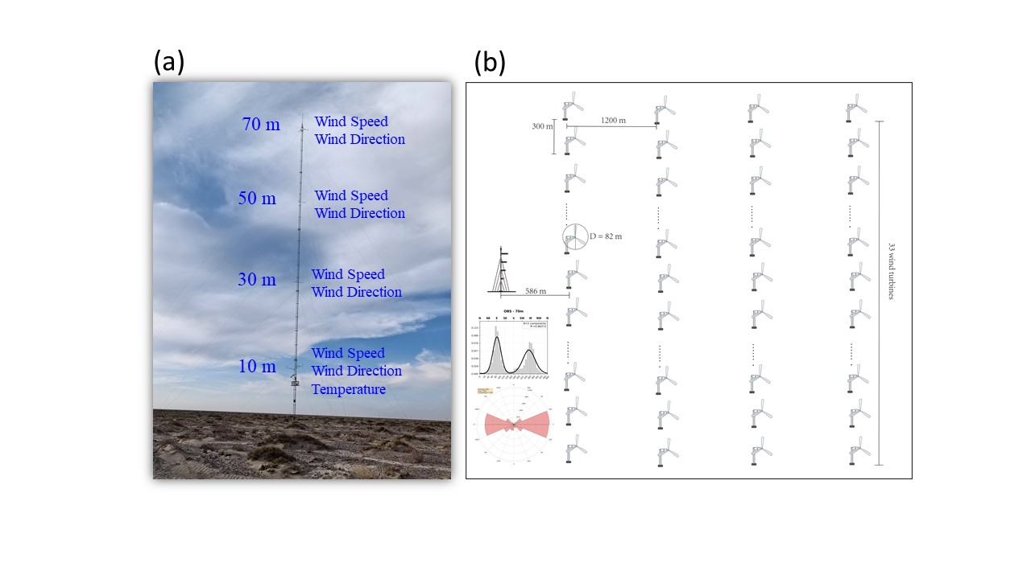
Figure S1. Observational setup and wind farm layout. (a) Photographic view of the 70-m meteorological mast equipped with anemometers and wind vanes at four vertical levels (10, 30, 50, and 70 m), and a temperature sensor at 10 m. (b) Schematic diagram of the wind farm layout illustrating the relative position of the mast (red triangle/structure on the left) to the turbine array. The mast is located 586 m west of the first turbine row, establishing a clear distinction between free-stream inflow (Westerly winds) and wake-affected flow (Easterly winds). The embedded wind rose displays the prevailing wind directions at the site.

References
Ke, G., Meng, Q., Finley, T., Wang, T., Chen, W., Ma, W., et al. (2017). Lightgbm: a highly efficient gradient boosting decision tree. Advances in Neural Information Processing Systems, 30.
Liao, W., Fang, J., Ye, L., Bak-Jensen, B., Yang, Z., & Porte-Agel, F. (2024). Can we trust explainable artificial intelligence in wind power forecasting? Applied Energy, 376, 124273. https://doi.org/10.1016/j.apenergy.2024.124273
Lundberg, S. M., & Lee, S.-I. (2017). A unified approach to interpreting model predictions. Advances in Neural Information Processing Systems, 30.
Torres, M. E., Colominas, M. A., Schlotthauer, G., & Flandrin, P. (2011). A complete ensemble empirical mode decomposition with adaptive noise. In 2011 IEEE International Conference on Acoustics, Speech and Signal Processing (ICASSP) (pp. 4144–4147). Prague, Czech Republic: IEEE. https://doi.org/10.1109/ICASSP.2011.5947265
Wilks, D. S. (2011). Statistical methods in the atmospheric sciences (Vol. 100). Academic press.
Wu, Z., & Huang, N. E. (2009). Ensemble empirical mode decomposition: a noise-assisted data analysis method. Advances in Adaptive Data Analysis, 1(1), 1–41. https://doi.org/10.1142/S1793536909000047

